**Bugs in “demo.vuestorefront” Website:**

**Identifier:** **1**

**Title:**

Application does not responses upon clicking the “Help & FAQ’s” button.

**Reported On:**

July 23, 2022

**Reported By:**

Idrees  
**Test Item:**

Homepage > Help & FAQ’s

**Environment:**

Windows 10, Google Chrome browser

**Description:**

1. Open browser.  
   **2)** Go for demo.vuestorefront.io   
   **3)** Click on the “Help & FAQ’s” button on the top left corner.  
   **4)** Notice that the button doesn’t give any response.

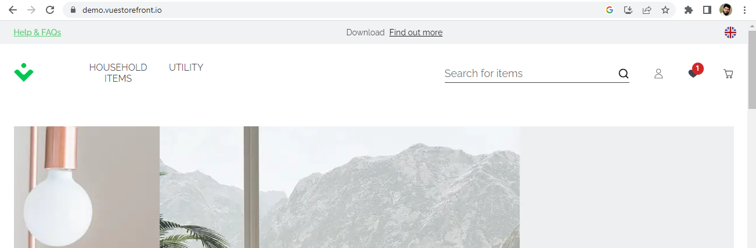

**Expected Result:**

On clicking the “Help & FAQ’s” button, you should be prompted to a new page showing the questions of some users and the answers by other users and company itself.

**Actual Result:**

ThisButton is not functional

**Severity:**

Low  
**Priority:**

Low

**Status:**

Awaiting Review

**Identifier:** **2**

**Title:**

Application does not responses upon clicking the “Find out more” button.

**Reported On:**

July 23, 2022

**Reported By:**

Idrees   
**Test Item:**

Homepage > Find out more

**Environment:**

Windows 10, Google Chrome browser

**Description:**

1. Open browser.  
   **2)** Go for demo.vuestorefront.io   
   **3)** Click on the “Find out more” button on the top left corner.  
   **4)** Notice that the button doesn’t give any response.



**Expected Result:**

On clicking the “Find out more” button, you should be prompted to a new page showing about all the products that are available on this website.

**Actual Result:**

ThisButton is not functional.

**Severity:**

Low  
**Priority:**

Low

**Status:**

Awaiting Review

**Identifier:** **3**

**Title:**

Application does not responses upon clicking the “Who we are” button.

**Reported On:**

July 23, 2022

**Reported By:**

Idrees  
**Test Item:**

Homepage > footer > Who we are

**Environment:**

Windows 10, Google Chrome browser

**Description:**

1. Open browser.  
   **2)** Go for demo.vuestorefront.io   
   **3)** Click on the “Who we are” button in the footer.  
   **4)** Notice that the button doesn’t give any response.

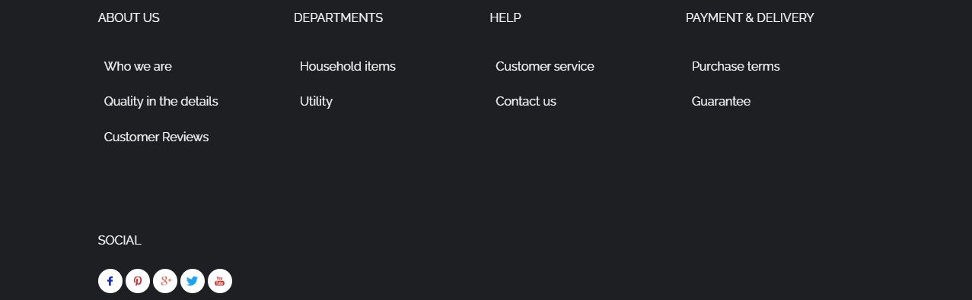

**Expected Result:**

On clicking the “Who we are” button, you should be prompted to a new page showing about all the company.

**Actual Result:**

ThisButton is not functional.

**Severity:**

Low  
**Priority:**

Low

**Status:**

Awaiting Review

**Identifier:** **4**

**Title:**

Application does not responses upon clicking the “Quality in the Details” button.

**Reported On:**

July 23, 2022

**Reported By:**

Idrees   
**Test Item:**

Homepage > footer > Quality in the Details

**Environment:**

Windows 10, Google Chrome browser

**Description:**

1. Open browser.  
   **2)** Go for demo.vuestorefront.io   
   **3)** Click on the “Quality in the Details” button in the footer section.  
   **4)** Notice that the button doesn’t give any response.



**Expected Result:**

On clicking the “Quality in the Details” button, you should be prompted to a new page showing all about the quality.

**Actual Result:**

ThisButton is not functional.

**Severity:**

Low  
**Priority:**

Low

**Status:**

Awaiting Review

**Identifier:** **5**

**Title:**

Application does not responses upon clicking the “Customer Reviews” button.

**Reported On:**

July 23, 2022

**Reported By:**

Idrees   
**Test Item:**

Homepage > footer > Customer Reviews

**Reason:**

Defect

**Environment:**

Windows 10, Google Chrome browser

**Description:**

1. Open browser.  
   **2)** Go for demo.vuestorefront.io   
   **3)** Click on the “Customer reviews” button in the footer section.  
   **4)** Notice that the button doesn’t give any response.



**Expected Result:**

On clicking the “Customer Reviews” button, you should be prompted to a new page showing all the feedback given by customers.

**Actual Result:**

ThisButton is not functional.

**Severity:**

Low  
**Priority:**

Low

**Status:**

Awaiting Review

**Identifier:** **6**

**Title:**

Application does not responses upon clicking the “Household Items” button in footer.

**Reported On:**

July 23, 2022

**Reported By:**

Idrees   
**Test Item:**

Homepage > footer > Household Items

**Environment:**

Windows 10, Google Chrome browser

**Description:**

1. Open browser.  
   **2)** Go for demo.vuestorefront.io   
   **3)** Click on the “Household Items” button in the footer section.  
   **4)** Notice that the button doesn’t give any response.



**Expected Result:**

On clicking the “Household Items” button, you should be prompted to a new page showing all the Household Items given by website for purchasing.

**Actual Result:**

ThisButton is not functional.

**Severity:**

Low  
**Priority:**

Low

**Status:**

Awaiting Review

**Identifier:** **7**

**Title:**

Application does not responses upon clicking the “Utility” button in footer.

**Reported On:**

July 23, 2022

**Reported By:**

Idrees  
**Test Item:**

Homepage > footer > Utility

**Reason:**

Defect

**Environment:**

Windows 10, Google Chrome browser

**Description:**

1. Open browser.  
   **2)** Go for demo.vuestorefront.io   
   **3)** Click on the “Utility” button in the footer section.  
   **4)** Notice that the button doesn’t give any response.



**Expected Result:**

On clicking the “Utility” button, you should be prompted to a new page showing all the Utility Items given by website for purchasing.

**Actual Result:**

ThisButton is not functional.

**Severity:**

Low  
**Priority:**

Low

**Status:**

Awaiting Review

**Identifier:** **8**

**Title:**

Application does not responses upon clicking the “Customer Service” button in footer.

**Reported On:**

July 23, 2022

**Reported By:**

Idrees  
**Test Item:**

Homepage > footer > Customer Service

**Environment:**

Windows 10, Google Chrome browser

**Description:**

1. Open browser.  
   **2)** Go for demo.vuestorefront.io   
   **3)** Click on the “Customer Service” button in the footer section.  
   **4)** Notice that the button doesn’t give any response.



**Expected Result:**

On clicking the “Customer Service” button, you should be prompted to a new page showing all the Customer Services that website is providing to its customers.

**Actual Result:**

ThisButton is not functional.

**Severity:**

Low  
**Priority:**

Low

**Status:**

Awaiting Review

**Identifier:** **9**

**Title:**

Application does not responses upon clicking the “Contact Us” button in footer.

**Reported On:**

July 23, 2022

**Reported By:**

Idrees   
**Test Item:**

Homepage > footer > Contact Us

**Environment:**

Windows 10, Google Chrome browser

**Description:**

1. Open browser.  
   **2)** Go for demo.vuestorefront.io   
   **3)** Click on the “Contact Us” button in the footer section.  
   **4)** Notice that the button doesn’t give any response.



**Expected Result:**

On clicking the “Contact Us” button, you should be prompted to a new page showing all the Contact information like mobile number, landline, email that the website has.

**Actual Result:**

ThisButton is not functional.

**Severity:**

Low  
**Priority:**

Low

**Status:**

Awaiting Review

**Identifier:** **10**

**Title:**

Application does not responses upon clicking the “Purchase Terms” button in footer.

**Reported On:**

July 23, 2022

**Reported By:**

Idrees  
**Test Item:**

Homepage > footer > Purchase Terms

**Reason:**

Defect

**Environment:**

Windows 10, Google Chrome browser

**Description:**

1. Open browser.  
   **2)** Go for demo.vuestorefront.io   
   **3)** Click on the “Purchase Terms” button in the footer section.  
   **4)** Notice that the button doesn’t give any response.



**Expected Result:**

On clicking the “Purchase Terms” button, you should be prompted to a new page showing all the Purchase Terms and information regarding policies.

**Actual Result:**

ThisButton is not functional.

**Severity:**

Low  
**Priority:**

Low

**Status:**

Awaiting Review

**Identifier:** **11**

**Title:**

Showing irrelevant data from navigation

**Reported On:**

July 24, 2022

**Reported By:**

Idrees  
**Test Item:**

Homepage > Household Items > Bath

**Reason:**

Defect

**Environment:**

Windows 10, Google Chrome browser

**Description:**

1. Open browser.  
   **2)** Go for demo.vuestorefront.io   
   **3)** Click on the “Household Items” button.  
   **4)** Select the “Bath” option.

**5)** Notice that the second product (Mug) it is showing belongs to an irrelevant category.

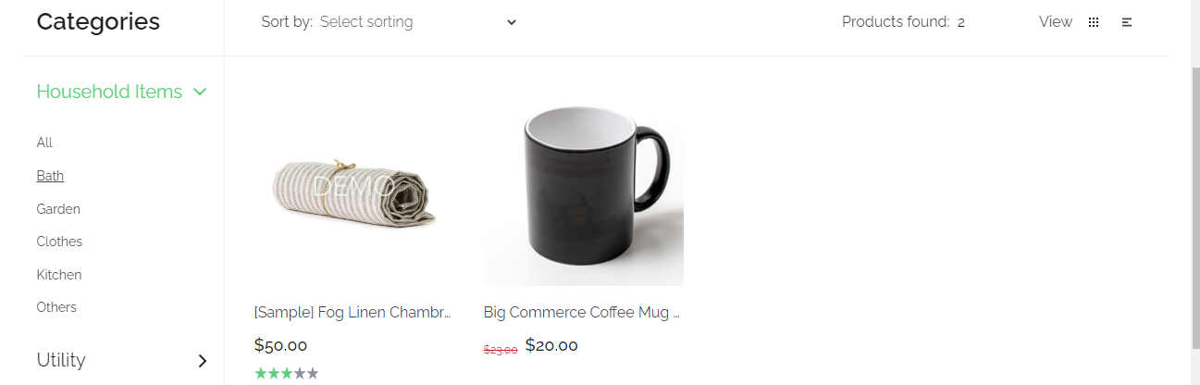

**Expected Result:**

On clicking the “Bath” button, you should be prompted to a new page showing all the categories relating to bathroom.

**Actual Result:**

ThisButton is giving wrong functionality.

**Severity:**

Low  
**Priority:**

Low

**Status:**

Awaiting Review

**Identifier:** **12**

**Title:**

Showing irrelevant data from navigation

**Reported On:**

July 24, 2022

**Reported By:**

Idrees  
**Test Item:**

Homepage > Household Items > Clothes

**Reason:**

Defect

**Environment:**

Windows 10, Google Chrome browser

**Description:**

1. Open browser.  
   **2)** Go for demo.vuestorefront.io   
   **3)** Click on the “Household Items” button.  
   **4)** Select the “Clothes” option.

**5)** Notice that all the products it is showing belong to irrelevant category.

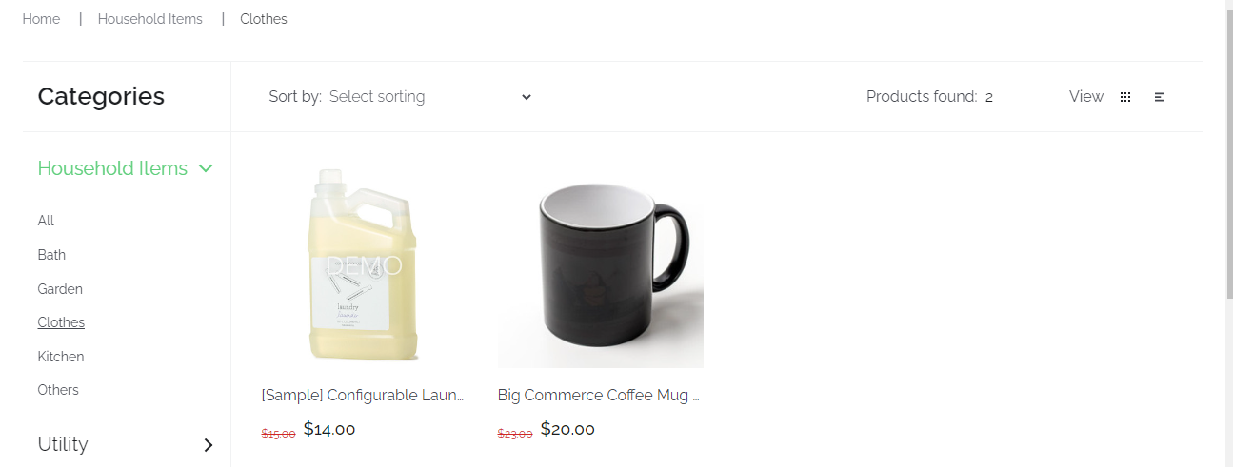

**Expected Result:**

On clicking the “Clothes” button, you should be prompted to a new page showing all the categories relating to clothes.

**Actual Result:**

ThisButton is giving wrong functionality.

**Severity:**

Low  
**Priority:**

Low

**Status:**

Awaiting Review

**Identifier:** **13**

**Title:**

Showing irrelevant data from navigation

**Reported On:**

July 24, 2022

**Reported By:**

Idrees  
**Test Item:**

Homepage > Utility > Publications

**Reason:**

Defect

**Environment:**

Windows 10, Google Chrome browser

**Description:**

1. Open browser.  
   **2)** Go for demo.vuestorefront.io   
   **3)** Click on the “Utility” button.  
   **4)** Select the “Publications” option.

**5)** Notice that all the products it is showing belong to irrelevant category.

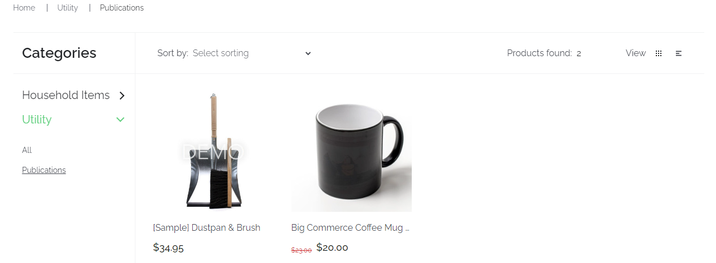

**Expected Result:**

On clicking the “Publications” button, you should be prompted to a new page showing all the categories relating to publications.

**Actual Result:**

ThisButton is giving wrong functionality.

**Severity:**

Low  
**Priority:**

Low

**Status:**

Awaiting Review

**Identifier:** **14**

**Title:**

Application does not responses upon clicking the “Facebook” social icon in footer.

**Reported On:**

July 24, 2022

**Reported By:**

Idrees  
**Test Item:**

Homepage > Footer > Social > Facebook

**Reason:**

Defect

**Environment:**

Windows 10, Google Chrome browser

**Description:**

1. Open browser.  
   **2)** Go for demo.vuestorefront.io   
   **3)** Click on the “Facebook” icon in social section of the footer.  
   **4)** Notice that the icon doesn’t give any response.



**Expected Result:**

On clicking the “Facebook” icon, you should be prompted to a Facebook page showing the Facebook Page/Group/Profile of the website.

**Actual Result:**

Thisicon is not functional.

**Severity:**

Low  
**Priority:**

Low

**Status:**

Awaiting Review

**Identifier:** **15**

**Title:**

Application does not responses upon clicking the “Pinterest” social icon in footer.

**Reported On:**

July 24, 2022

**Reported By:**

Idrees  
**Test Item:**

Homepage > Footer > Social > Pinterest

**Reason:**

Defect

**Environment:**

Windows 10, Google Chrome browser

**Description:**

1. Open browser.  
   **2)** Go for demo.vuestorefront.io   
   **3)** Click on the “Pinterest” icon in social section of the footer.  
   **4)** Notice that the icon doesn’t give any response.



**Expected Result:**

On clicking the “Pinterest” icon, you should be prompted to a Pinterest page showing the Pinterest Page/Group/Profile of the website.

**Actual Result:**

Thisicon is not functional.

**Severity:**

Low  
**Priority:**

Low

**Status:**

Awaiting Review

**Identifier:** **16**

**Title:**

Application does not responses upon clicking the “Google+” social icon in footer.

**Reported On:**

July 24, 2022

**Reported By:**

Idrees  
**Test Item:**

Homepage > Footer > Social > Google+

**Reason:**

Defect

**Environment:**

Windows 10, Google Chrome browser

**Description:**

1. Open browser.  
   **2)** Go for demo.vuestorefront.io   
   **3)** Click on the “Google+” icon in social section of the footer.  
   **4)** Notice that the icon doesn’t give any response.



**Expected Result:**

On clicking the “Google+” icon, you should be prompted to a Google+ page showing the Google+ Profile of the website.

**Actual Result:**

Thisicon is not functional.

**Severity:**

Low  
**Priority:**

Low

**Status:**

Awaiting Review

**Identifier:** **17**

**Title:**

Application does not responses upon clicking the “Twitter” social icon in footer.

**Reported On:**

July 24, 2022

**Reported By:**

Idrees  
**Test Item:**

Homepage > Footer > Social > Twitter

**Reason:**

Defect

**Environment:**

Windows 10, Google Chrome browser

**Description:**

1. Open browser.  
   **2)** Go for demo.vuestorefront.io   
   **3)** Click on the “Twitter” icon in social section of the footer.  
   **4)** Notice that the icon doesn’t give any response.



**Expected Result:**

On clicking the “Twitter” icon, you should be prompted to a Twitter page showing the Twitter Profile of the website.

**Actual Result:**

Thisicon is not functional.

**Severity:**

Low  
**Priority:**

Low

**Status:**

Awaiting Review

**Identifier:** **18**

**Title:**

Application does not responses upon clicking the “YouTube” social icon in footer.

**Reported On:**

July 24, 2022

**Reported By:**

Idrees  
**Test Item:**

Homepage > Footer > Social > YouTube

**Reason:**

Defect

**Environment:**

Windows 10, Google Chrome browser

**Description:**

1. Open browser.  
   **2)** Go for demo.vuestorefront.io   
   **3)** Click on the “YouTube” icon in social section of the footer.  
   **4)** Notice that the icon doesn’t give any response.



**Expected Result:**

On clicking the “YouTube” icon, you should be prompted to a YouTube page showing the YouTube Channel of the website.

**Actual Result:**

Thisicon is not functional.

**Severity:**

Low  
**Priority:**

Low

**Status:**

Awaiting Review